W4 과제

Y2021010 이유린

|  |  |  |  |  |  |  |  |  |  |  |
| --- | --- | --- | --- | --- | --- | --- | --- | --- | --- | --- |
| **Bankruptcy 데이터를 활용한 로지스틱 회귀분석과 다중판별분석 학습 결과**  **Independent Samples Test** | | | | | | | | | | |
|  | | Levene's Test for Equality of Variances | | t-test for Equality of Means | | | | | | |
| F | Sig. | t | df | Sig. (2-tailed) | Mean Difference | Std. Error Difference | 95% Confidence Interval of the Difference | |
| Lower | Upper |
| X13_1 | Equal variances assumed | 10.304 | .001 | 7.702 | 2668 | .000 | .309 | .040 | .231 | .388 |
| Equal variances not assumed |  |  | 7.702 | 2639.670 | .000 | .309 | .040 | .231 | .388 |
| X18_1 | Equal variances assumed | .089 | .766 | 3.957 | 2668 | .000 | .161 | .041 | .081 | .241 |
| Equal variances not assumed |  |  | 3.957 | 2666.936 | .000 | .161 | .041 | .081 | .241 |
| X36_1 | Equal variances assumed | 5.905 | .015 | -17.338 | 2668 | .000 | -.663 | .038 | -.738 | -.588 |
| Equal variances not assumed |  |  | -17.338 | 2656.894 | .000 | -.663 | .038 | -.738 | -.588 |
| X42_1 | Equal variances assumed | 9.866 | .002 | 16.920 | 2668 | .000 | .630 | .037 | .557 | .703 |
| Equal variances not assumed |  |  | 16.920 | 2623.871 | .000 | .630 | .037 | .557 | .703 |
| X43_1 | Equal variances assumed | 14.777 | .000 | -4.022 | 2668 | .000 | -.152 | .038 | -.226 | -.078 |
| Equal variances not assumed |  |  | -4.022 | 2572.209 | .000 | -.152 | .038 | -.226 | -.078 |
| X74_1 | Equal variances assumed | 46.748 | .000 | -6.346 | 2668 | .000 | -.255 | .040 | -.333 | -.176 |
| Equal variances not assumed |  |  | -6.346 | 2568.903 | .000 | -.255 | .040 | -.333 | -.176 |
| X76_1 | Equal variances assumed | 72.890 | .000 | 7.797 | 2668 | .000 | .321 | .041 | .240 | .401 |
| Equal variances not assumed |  |  | 7.797 | 1975.512 | .000 | .321 | .041 | .240 | .401 |
| X98_1 | Equal variances assumed | 526.299 | .000 | -18.779 | 2668 | .000 | -.700 | .037 | -.774 | -.627 |
| Equal variances not assumed |  |  | -18.779 | 1676.725 | .000 | -.700 | .037 | -.774 | -.627 |
| X107_1 | Equal variances assumed | 54.777 | .000 | -4.889 | 2668 | .000 | -.195 | .040 | -.273 | -.117 |
| Equal variances not assumed |  |  | -4.889 | 2367.449 | .000 | -.195 | .040 | -.273 | -.117 |
| X118_1 | Equal variances assumed | 98.170 | .000 | 14.720 | 2668 | .000 | .589 | .040 | .510 | .667 |
| Equal variances not assumed |  |  | 14.720 | 2350.238 | .000 | .589 | .040 | .510 | .667 |
| X129_1 | Equal variances assumed | 61.703 | .000 | 22.344 | 2668 | .000 | .820 | .037 | .748 | .892 |
| Equal variances not assumed |  |  | 22.344 | 2530.915 | .000 | .820 | .037 | .748 | .892 |
| X130_1 | Equal variances assumed | 1.149 | .284 | 22.847 | 2668 | .000 | .830 | .036 | .759 | .901 |
| Equal variances not assumed |  |  | 22.847 | 2667.315 | .000 | .830 | .036 | .759 | .901 |
| X133_1 | Equal variances assumed | 17.515 | .000 | 6.506 | 2668 | .000 | .258 | .040 | .181 | .336 |
| Equal variances not assumed |  |  | 6.506 | 2591.357 | .000 | .258 | .040 | .181 | .336 |
| X149_1 | Equal variances assumed | 60.552 | .000 | 5.951 | 2668 | .000 | .231 | .039 | .155 | .308 |
| Equal variances not assumed |  |  | 5.951 | 2499.312 | .000 | .231 | .039 | .155 | .308 |
| X157_1 | Equal variances assumed | .108 | .743 | -1.197 | 2668 | .231 | -.049 | .041 | -.130 | .032 |
| Equal variances not assumed |  |  | -1.197 | 2661.365 | .231 | -.049 | .041 | -.130 | .032 |

Bankruptcy 데이터들의 변수를 독립표본 t 검정으로 분석한 결과 변수 X157_1은 0.231으로 유의한 차이가 없다고 나옴.

**로지스틱 회귀분석**

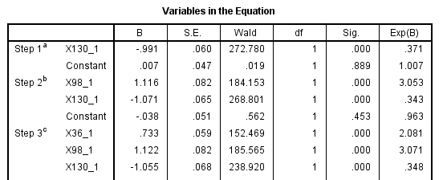

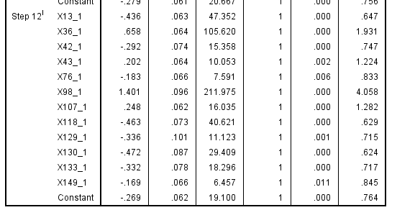

X18_1, X74_1, X157_1은 생략됨

X98_1가 부도예측에 가장 큰 영향을 끼친다. (높을수록 부도가 날 확률이 높음)

**다중판별분석**

|  |  |  |  |  |  |  |
| --- | --- | --- | --- | --- | --- | --- |
| **Classification Resultsa,b** | | | | | | |
|  |  |  | Y | Predicted Group Membership | | Total |
|  |  |  | 0 | 1 |
| Cases Selected | Original | Count | 0 | 844 | 223 | 1067 |
| 1 | 169 | 898 | 1067 |
| cv% | 0 | 79.1 | 20.9 | 100.0 |
| 1 | 15.8 | 84.2 | 100.0 |
| Cases Not Selected | Original | Count | 0 | 219 | 49 | 268 |
| 1 | 42 | 226 | 268 |
| % | 0 | 81.7 | 18.3 | 100.0 |
| 1 | 15.7 | 84.3 | 100.0 |
| a. 81.6% of selected original grouped cases correctly classified. | | | | | | |
| b. 83.0% of unselected original grouped cases correctly classified. | | | | | | |

**선택된 집단 케이스 중 81.6%가 올바로 분류**

**비선택 집단 케이스 중 83.0%가 올바로 분류**